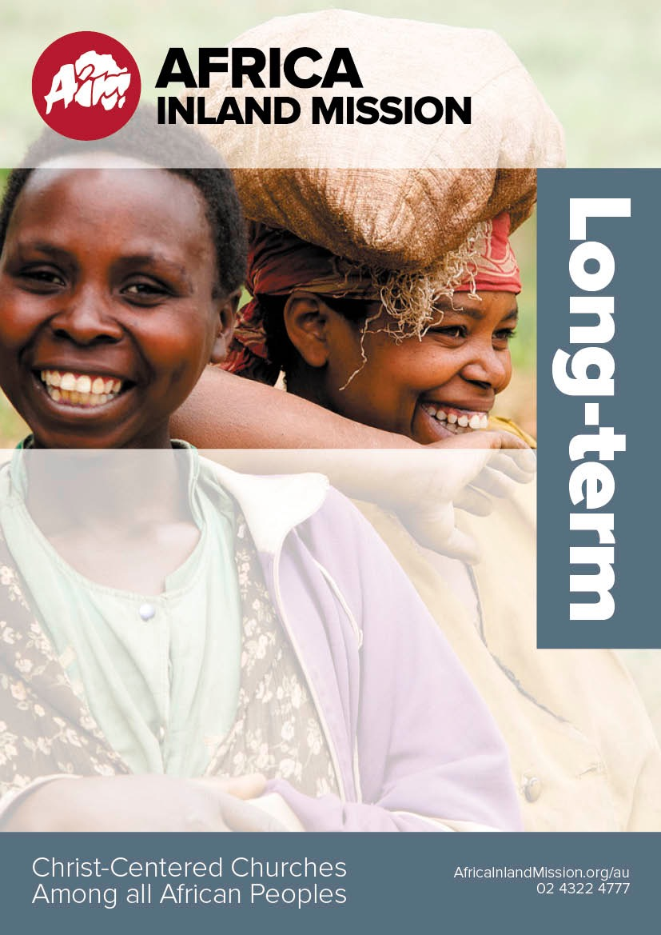

Updated

Sept 2017

*Ministry Team can suit new, experienced and even short-term workers.*

Tanzania Coastal Swahili MINISTRY team – Gospel proclamation is paramount in this outreach team. The team will focus on Bible storying, no-till farming, English teaching or health care as means of contact with the community. New members can join the team anytime.

Kenya Marsabit Ministry team – Working among an unreached people group. AIM is looking for particular individuals to fill roles: 2 Bible teachers, 1 Engineer for building and training, 2 Medical workers and 1 Children’s worker. This is an open-ended team.

Nyamwezi Tanzania Ministry Team – Ministry team is in partnership with the African Inland Church of Tanzania. Members will be involved in training local pastors and reaching local people through community development in farming, water health and education. This is an open-ended team.

Inquire now: [director.au@aimint.org](mailto:director.au@aimint.org) or [admin.nz@aimint.org](mailto:director.nz@aimint.org)