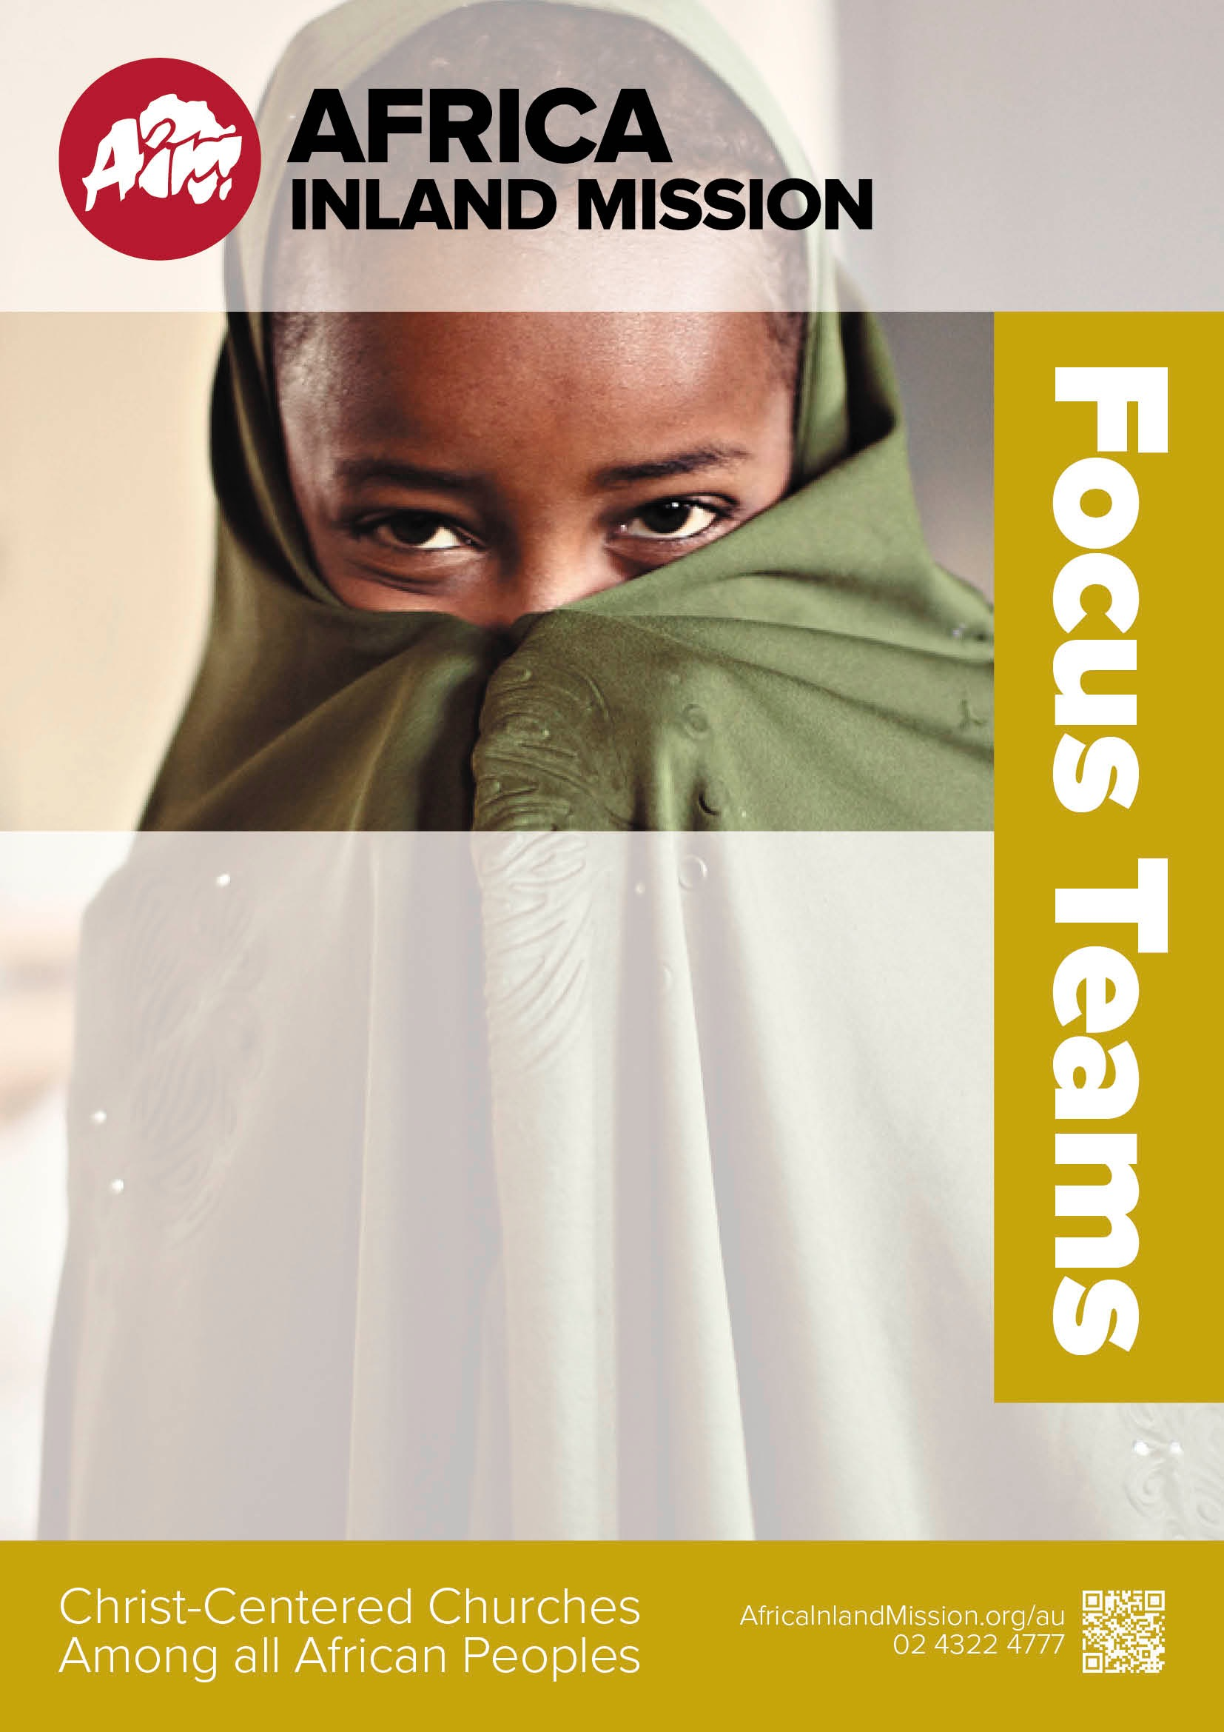

Updated

Sept 2017

*Focus on planting churches among an unreached people group in Africa.*

Island English Teaching Team – Trained and experienced teachers and TESL workers needed. Starts: mid 2017 to early 2018.

Island Medical Team – Medical workers to serve in a hospital and medical centres on an Indian Ocean Island. Starts: mid 2018.

Detroit Metro Focus Team **–** Help the Detroit church in the USA become trained, equipped and active in cross-cultural disciple making among the least reached peoples.

South Sudan Torit Focus Team – Discipling church leaders to grow a vision for outreaching in their areas and do mission to unreached people groups – ongoing start times.

Philadelphia Focus Team **–** Ministry to North Africans in the US - ongoing start times.

Inquire now: [director.au@aimint.org](mailto:director.au@aimint.org) or [admin.nz@aimint.org](mailto:director.nz@aimint.org)